### Electron App Setup Guide ###

Sound Settings in windows 10:

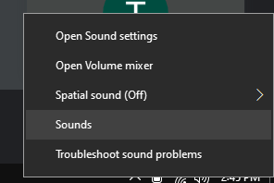

Go to Sounds

Then go to Playback tab:

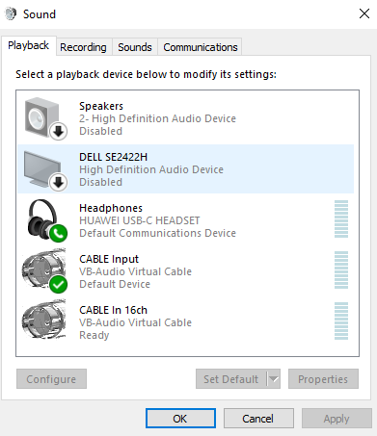

It should look like this.
I’ve added the disabled to unused devices so it can’t get confused, probably not necessary.

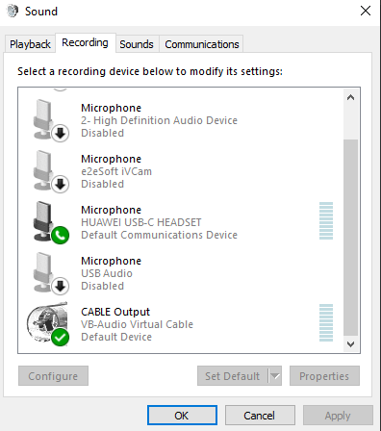

Then go to Recording.

Should look like this.

Again, added the disabled for devices not in use, probably not necessary.

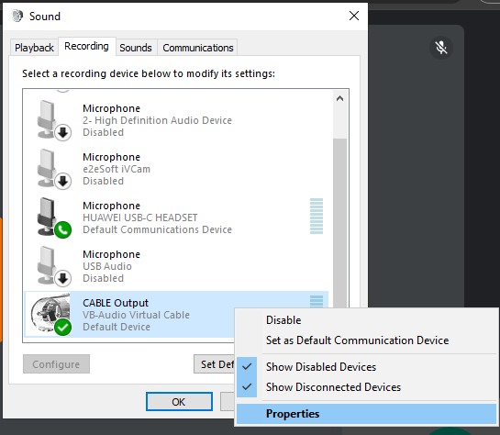

Then Right click properties on CABLE Output.

Then go to Listen tab, setup should look as follow:

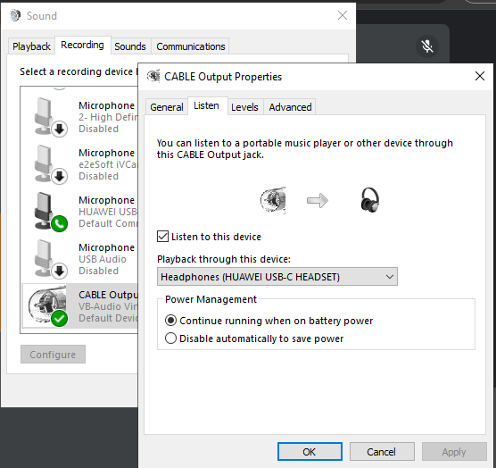

Lastly sound can be either Headphones (HUAWEI USB-C HEADSET) or CABLE Input (VB-Audio Virtual Cable).

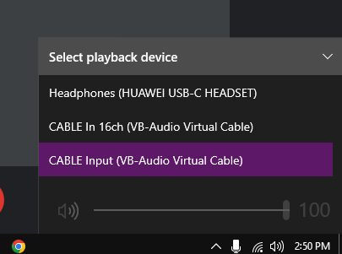

Now for in meeting setup around mic and playback, this is essential otherwise it won’t work. Especially around the playback.

Google Meet Setup:

Mic Input:

Needs to be Microphone (HUAWEI USB-C HEADSET) otherwise mic input is not picked up and they can’t hear you.
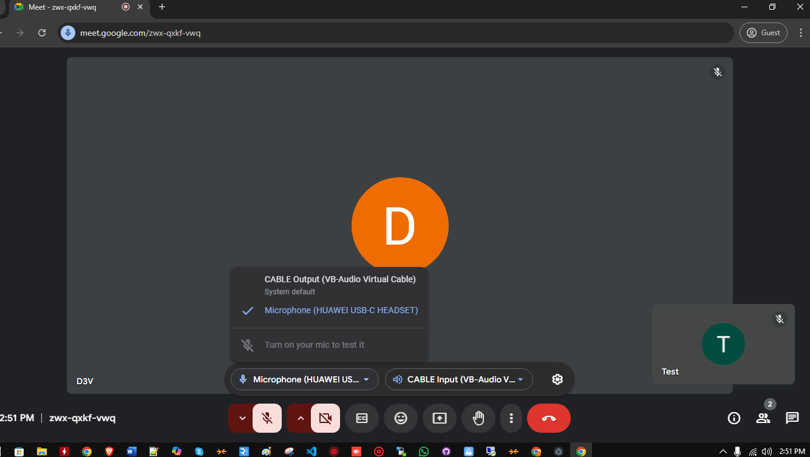

Speaker/playback:

Needs to be CABLE Input (VB-Audio Virtual Cable), otherwise won’t pickup audio for transcriber (whisper-1 Open AI).

